**LAB 5**

## Question no. 1:

**For the Boolean functions implement the circuit on Logic Work 4 and make a truth table.**

**F2 = [(A.(B+C’)+(A’+C’)]’. C**

**Truth Table:**

|  |  |  |  |  |  |  |  |
| --- | --- | --- | --- | --- | --- | --- | --- |
| **A** | **B** | **C** | **B+C’** | **A’+C’** | **A.(B+C’)** | **[A.(B+C’)+(A’+C’)]’** | **F2** |
| 0 | 0 | 0 | 1 | 1 | 0 | 0 | **0** |
| 0 | 0 | 1 | 0 | 1 | 0 | 0 | **0** |
| 0 | 1 | 0 | 1 | 1 | 0 | 0 | **0** |
| 0 | 1 | 1 | 1 | 1 | 0 | 0 | **0** |
| 1 | 0 | 0 | 1 | 1 | 1 | 0 | **0** |
| 1 | 0 | 1 | 0 | 0 | 0 | 1 | **1** |
| 1 | 1 | 0 | 1 | 1 | 1 | 0 | **0** |
| 1 | 1 | 1 | 1 | 0 | 1 | 0 | **0** |

**Circuit:**

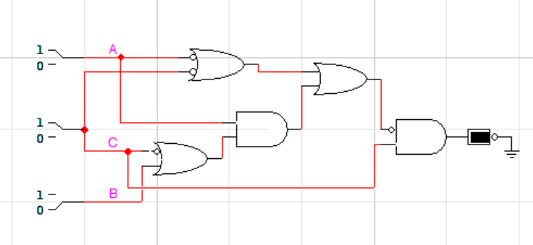

## Question no. 2:

**Find Max terms from the following Min terms**

1. **F(X,Y,Z) =Σm(1,3,5,7)**

F’(X,Y,Z) =Σm(0,2,4,6)

F(X,Y,Z)= πM(0,2,4,6)

1. **F(X,Y,Z) =Σm(0,2,4,6,7)**

F’(X,Y,Z) =Σm(1,3,5)

F(X,Y,Z)= πM(1,3,5)

1. **F(A,B,C) =Σm(0,1,3,4,5,7)**

F(A,B,C) =Σm(2,6)

F’(A,B,C)= πM(2,6)

## Question no. 3:

**For the Boolean function $F1(A,B,C)=\sum{m\left(0,2,3,4,6\right)+d(7)}$ do the following:**

1. **Find truth table**

|  |  |  |  |  |  |  |  |  |  |  |
| --- | --- | --- | --- | --- | --- | --- | --- | --- | --- | --- |
| **A** | **B** | **C** | **index** | **m0** | **m2** | **m3** | **m4** | **m6** | **m7** | **F1** |
| 0 | 0 | 0 | 0 | 1 | 0 | 0 | 0 | 0 | 0 | **1** |
| 0 | 0 | 1 | 1 | 0 | 0 | 0 | 0 | 0 | 0 | **0** |
| 0 | 1 | 0 | 2 | 0 | 1 | 0 | 0 | 0 | 0 | **1** |
| 0 | 1 | 1 | 3 | 0 | 0 | 1 | 0 | 0 | 0 | **1** |
| 1 | 0 | 0 | 4 | 0 | 0 | 0 | 1 | 0 | 0 | **1** |
| 1 | 0 | 1 | 5 | 0 | 0 | 0 | 0 | 0 | 0 | **0** |
| 1 | 1 | 0 | 6 | 0 | 0 | 0 | 0 | 1 | 0 | **1** |
| 1 | 1 | 1 | 7 | 0 | 0 | 0 | 0 | 0 | x | **x** |

1. **Find minimal SOP expression for Boolean function $F1$ using K-Maps and implement it on Logic Works 4**

**K-map:**

|  |  |  |  |  |
| --- | --- | --- | --- | --- |
|  | **B’C’** | **B’C** | **BC** | **BC’** |
| **A** | 1 |  | 1 | 1 |
| **A’** | 1 |  | x | 1 |

**Minimal SOP expression:**

F1=B+C’

**Circuit:**

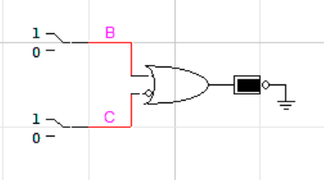

## Question no. 4:

**For the Boolean function $F1\left(A,B,C,D\right)=\sum{m\left(0,2,4,6,7,8,10,12,14,15\right)}+d(3,11)$ do the following:**

1. **Find truth table**

|  |  |  |  |  |  |  |  |  |  |  |  |  |  |  |  |  |  |
| --- | --- | --- | --- | --- | --- | --- | --- | --- | --- | --- | --- | --- | --- | --- | --- | --- | --- |
| **A** | **B** | **C** | **D** | **index** | **m 0** | **m 2** | **m 3** | **m 4** | **m 6** | **m 7** | **m 8** | **m 10** | **m 11** | **m 12** | **m 14** | **m 15** | **F1** |
| 0 | 0 | 0 | 0 | 0 | 1 | 0 | 0 | 0 | 0 | 0 | 0 | 0 | 0 | 0 | 0 | 0 | **1** |
| 0 | 0 | 0 | 1 | 1 | 0 | 0 | 0 | 0 | 0 | 0 | 0 | 0 | 0 | 0 | 0 | 0 | **0** |
| 0 | 0 | 1 | 0 | 2 | 0 | 1 | 0 | 0 | 0 | 0 | 0 | 0 | 0 | 0 | 0 | 0 | **1** |
| 0 | 0 | 1 | 1 | 3 | 0 | 0 | x | 0 | 0 | 0 | 0 | 0 | 0 | 0 | 0 | 0 | **x** |
| 0 | 1 | 0 | 0 | 4 | 0 | 0 | 0 | 1 | 0 | 0 | 0 | 0 | 0 | 0 | 0 | 0 | **1** |
| 0 | 1 | 0 | 1 | 5 | 0 | 0 | 0 | 0 | 0 | 0 | 0 | 0 | 0 | 0 | 0 | 0 | **0** |
| 0 | 1 | 1 | 0 | 6 | 0 | 0 | 0 | 0 | 1 | 0 | 0 | 0 | 0 | 0 | 0 | 0 | **1** |
| 0 | 1 | 1 | 1 | 7 | 0 | 0 | 0 | 0 | 0 | 1 | 0 | 0 | 0 | 0 | 0 | 0 | **1** |
| 1 | 0 | 0 | 0 | 8 | 0 | 0 | 0 | 0 | 0 | 0 | 1 | 0 | 0 | 0 | 0 | 0 | **1** |
| 1 | 0 | 0 | 1 | 9 | 0 | 0 | 0 | 0 | 0 | 0 | 0 | 0 | 0 | 0 | 0 | 0 | **0** |
| 1 | 0 | 1 | 0 | 10 | 0 | 0 | 0 | 0 | 0 | 0 | 0 | 1 | 0 | 0 | 0 | 0 | **1** |
| 1 | 0 | 1 | 1 | 11 | 0 | 0 | 0 | 0 | 0 | 0 | 0 | 0 | x | 0 | 0 | 0 | **x** |
| 1 | 1 | 0 | 0 | 12 | 0 | 0 | 0 | 0 | 0 | 0 | 0 | 0 | 0 | 1 | 0 | 0 | **1** |
| 1 | 1 | 0 | 1 | 13 | 0 | 0 | 0 | 0 | 0 | 0 | 0 | 0 | 0 | 0 | 0 | 0 | **0** |
| 1 | 1 | 1 | 0 | 14 | 0 | 0 | 0 | 0 | 0 | 0 | 0 | 0 | 0 | 0 | 1 | 0 | **1** |
| 1 | 1 | 1 | 1 | 15 | 0 | 0 | 0 | 0 | 0 | 0 | 0 | 0 | 0 | 0 | 0 | 1 | **1** |

1. **Find minimal SOP expression for Boolean function $F1$ using K-Maps and implement it on Logic Works 4**

**K-map:**

|  |  |  |  |  |
| --- | --- | --- | --- | --- |
|  | **C’D’** | **C’D** | **CD** | **CD’** |
| **A’B’** | 1 |  | x | 1 |
| **A’B** | 1 |  | 1 | 1 |
| **AB** | 1 |  | 1 | 1 |
| **AB’** | 1 |  | x | 1 |

**Minimal SOP expression:**

F1=C+D’

**Circuit:**

